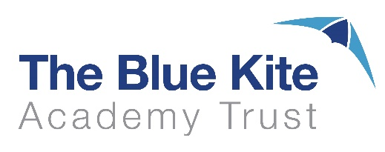

**Admission Policy 2026/27 - Consultation**

The Blue Kite Academy School now comprises of 25 Swindon and Wiltshire Schools (Infant, Junior and Primary) and a new admission policy for 2026/2027 has been written to incorporate Wanborough Primary School that joined the Trust on 1 July 2024 and the ten church schools that will join the Trust on 1 January 2025 – Christian Malford, Lydiard Millicent, Tadpole Farm , South Marston, St Leonards, Ridgeway Farm, Seagry, Somerford’s Walter Powell, Sutton Benger and St Peters CE Primary Schools.

There are two changes of Published Admission Numbers (PAN). Covingham Park Primary School will reduce from 60 to 45 and Even Swindon Primary School will reduce from 90 to 75.

There is one change to the oversubscription criteria for Sutton Benger CE Primary School *Children of staff will be considered, where the member of staff has worked at the academy for two or more years at the time at which the application for admission to Sutton Benger CE Academy is made, or the member of staff is recruited to fill a vacant post for which there is a demonstrable skill shortage* has been removed.

As a result of these changes, it is necessary to consult on this policy. The consultation will run from Wednesday 11 December 2024 to Friday 31 January 2025.

If you have any comments regarding the Admissions Policy for 2026/27 please email Anna Richardson, Head of Governance, [arichardson@bluekitetrust.org](mailto:arichardson@bluekitetrust.org)